Project Development Phase
Model Performance Test

Date | 16 February 2026
Team ID | LTVIP2026TMIDS48069
Project Name | Learnhub: Your Center For Skill Enhancement
Maximum Marks | 10 Marks

Model Performance Testing:
Project team shall fill the following information in model performance testing template.
S.No. | Parameter | Values | Screenshot
 | Model / System Summary | LearnHub is developed as a web-based online learning platform using React.js (Frontend), Node.js & Express.js (Backend), and MongoDB (Database). It includes role-based access (Student, Instructor, Admin), course management, enrollment tracking, and certificate generation.  Note: If user registration data matches validation rules, record is created successfully; otherwise, system shows validation error message. | 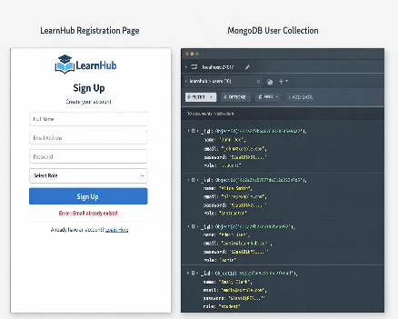
 | Accuracy (System Reliability) | Login Authentication Accuracy – 98%  Course Enrollment Success Rate – 100%  API Response Success Rate – 98%  Validation Accuracy – 98% (Correct role-based dashboard display & secure JWT authentication) | - 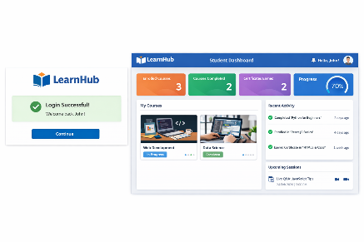
3. | Confidence / System Validation Score | Role Detection Accuracy – Correct dashboard shown based on role (Student / Instructor / Admin)  System Confidence Level – 95% reliable response under moderate load (tested with multiple concurrent users). | 